**ISEM 3006 Data Management in Business**

**Exercise 6**

**SQL DELETE, UPDATE and ER**

**Answers**

**For Q1 to Q3, use the Trustful Property Rental Company Database in Exercise 3.**

**Unless state otherwise, the case of strings is important, i.e. if I ask you to retrieve properties that are located in 'KLN', you only retrieve properties that are located in 'KLN', but not 'kln', 'Kln', 'kLn', etc.**

1. Update the type to ‘House’ and size to 2000 for the property with the property number equal to 3.

UPDATE Property

SET Type = 'House', Size = 2000

WHERE PropertyNo = 3;

1. Reduce the monthly rental by 20% for the properties having less than 3 viewings. After the update, the table should look like the following:

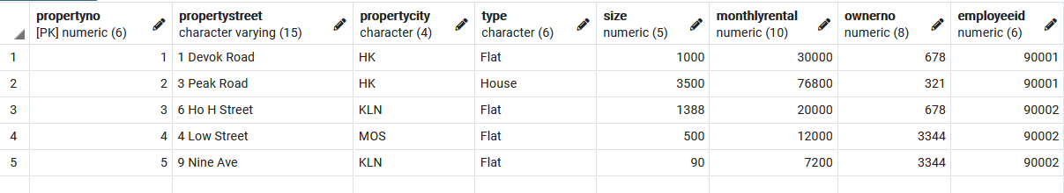

UPDATE Property

SET MonthlyRental = MonthlyRental * 0.8

WHERE PropertyNo IN (SELECT PropertyNo

FROM Viewing

GROUP BY PropertyNo

HAVING COUNT (*) < 3);

1. Delete the viewings of the properties for which the in-charge employee is employed by the branches located in the city ‘NT’.

After the DELETE, the Viewing table should contain the following records:

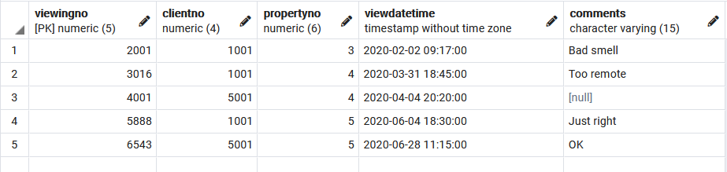

DELETE FROM Viewing

WHERE PropertyNo IN (SELECT P.PropertyNo

FROM Property P JOIN Employee E

ON P.EmployeeID = E.EmployeeID

JOIN Branch B

ON E.BranchCode = B.BranchCode

WHERE B.BranchCity = 'NT');

For Q3 and Q4, develop Entity-Relationship Model based on the description; resolve the many-to-many relationships in the ER model that you developed. List the attributes of the entity types, underline the primary key, and put the foreign keys into the proper place.

1. The BU Art Museum owns a large volume of works of art, such as painting and sculpture. Each work of art is described by a unique item code, title, date of acquisition, and type (such as painting and sculpture, photograph, etc.). Moreover, at any point in time, a work of art is either on display at the museum, held in storage, or away from the museum as part of a travelling show. Whereabouts of the work of art needs to be recorded. A travelling show is described by a unique show ID, city in which the show is currently appearing, and the start and end dates of the show. Many of the museum works may be part of a given show, and only active shows with at least one museum work of art need be recorded in the database. A work of art is developed by an artist, but the artist for some works is unknown. An artist is described by a unique artist ID, name, date of birth, and date of death (which is null for still living artists). Only data about artists for works currently owned by the museum are kept in the database.

Note: The Artwork Status records whereabouts of the artwork, i.e., the values can be ‘on display’, ‘in storage’ or ‘in a travelling show’.



4. RunRunRun (RRR) Car Maintenance System:

RunRunRun (RRR) owns a fleet of cars which is used in its business. All car maintenance is performed by RRR itself. You are asked to help designing the database to support the car maintenance system.

RRR owns around 20 cars now and is expanding. Each car is identified by a car ID. It also has a plate number, the year it was purchased, the cost of purchasing the car, a category (such as sedan, RV, etc.), and the number of seats.

Each time a car requires maintenance, a maintenance log entry is created. The maintenance log include a unique maintenance number, a description, the car ID, the request date, and the odometer reading of the car. The date on which the maintenance was completed will be updated after the mechanics finish the maintenance. A new car may not need any maintenance yet. However, an old car may already has a lot of maintenances.

Each maintenance is served by one or more mechanics that the RRR employed. A newly employed mechanic may not be assigned to any maintenance yet. The hours that a mechanic spends on a maintenance needs to be recorded. Each mechanic has a unique mechanic ID. The name, gender, age, and position is also recorded. A mechanic may supervise other mechanics. Of course, a mechanic may supervise no one if he or she is not a supervisor. However, a mechanic has at most one supervisor.

Each maintenance might generate a number of maintenance jobs that need to be performed. For example, a maintenance may generate a job to replace the windshield wiper and another job to replace a tire. Obvious, a maintenance will generate at least one job. A job has a unique job number and also has a description and a finished date. Some maintenance jobs may use many parts, but some jobs may not need any part (e.g., tuning the engine). If a job uses parts, the quantity used for each part needs to be recorded. Some parts may have not yet used in any job.

RRR records the information about parts (like brake oil, air filters, windshield wiper etc.) The parts inventory is monitored so as to order parts that reach the "re-order quantity" level. A part is uniquely identified by a part number. The part name and quantity on hand are also recorded.

Many-to-Many relationships not resolved and have not put FKs in proper entity types:



Many-to-Many relationships resolved and have put FKs in proper entity types:

